**UNIVERSITY OF JAFFNA, SRI LANKA**

**Faculty of Engineering**



ACADEMIC CALENDAR MANAGEMENT SYSTEM

by

CUMARANATHUNGA P.I.A. (2018/E/022)

ERANDA A.H. (2018/E/031)

PERERA U.L.K.K. (2018/E/091)

SACHINTHA D.C. (2018/E/104)

SATHURJAN J. (2018/E/108)

A project proposal submitted to the

Department of Computer Engineering

In partial fulfillment of the requirements for the

course module EC6060 software engineering for the

Degree of Bachelor of Science of Engineering

June 08

**Introduction and Cover Letter**

Dr. S. Thananjeyan

Senior Lecturer

Department of Electrical and Electronic Engineering

Faculty of Engineering

University of Jaffna

Kavindya Perera

Leader – Team 01

Department of Computer Engineering

Faculty of Engineering

University of Jaffna

08th June 2022

Dear Dr. Thananjeyan,

Please find enclosed our detailed software proposal for your kind consideration.

At Department of Computer Engineering, Faculty of Engineering, University of Jaffna we are aware that creating **Academic Calendar Management System** software takes a mixture of technical excellence and clear communication and our team hires only the very best to ensure you receive both. We know that every client is unique and we strive to deliver an individual, innovative and affordable proposal and to follow it through with an outstanding delivery which is both on time and within budget.

We have more development in this area and our previous developments include theatre booking system in software construction, database management system projects

Please let us know if you would like to get in touch with our existing clients from whom you will receive nothing but positive endorsements. You may also wish to review our previous work and learn more about our development skills and knowledge.

We also pride ourselves on our after-sales client-care including our guarantees, staff-training and onsite and offsite support.

Finally, we realize that you are very busy and wanted to thank you in advance for your time spent reviewing our proposal.

Yours Truly,

Kavindya Perera

Computer Department

Faculty of Engineering, University of Jaffna.

**Executive Summary**

The modern world has been irrevocably shaped by technology and for good reason. Many long-standing problems in industries can be solved with the right program. It's not enough to simply use pre-existing solutions, however.

Create Academic calendar management system

After a thorough but efficient preparation period, our team finally decided to create an academic calendar management system for AR.

We are expecting to give our main focus specially on the semester periods, exam periods, holiday periods, course registration periods, and exam registration periods. The resulting software will achieve:

* Clear visualization of when the semester begins/ ends
* Clear visualization of exam periods
* Clear visualization of holiday periods
* Clear visualization of course registration open/close date and the duration
* Clear visualization of exam registration open/close date and the duration
* Feature to add/update/delete all the above periods

**Integrate MS Teams and Trello**

With the coordination with Dr. Thananjeyan, we got the use of both MS Teams and Trello for this project.

We will achieve the goals listed above by utilizing agile methodology. This process allows us to clearly visualize the academic calendar and edit the particular durations.

Up to now, planning we decided to complete this project within ten-week time.

**Technical obstacles**

**Technical skills**

For this project we have to work with a particular tech stack which every member of the team might not be familiar with. Being familiar with the stack and being able to develop the requirements can be a bit of a challenge under the current deadlines.

**Integration Issues**

It might be a challenge to integrate what we are making with tools currently existing. We have to find ways to make our product compatible using APIs so the app can be used in other products as an external module.

**Industry and market risks**

Following are some of the applications already exist for calendar management purpose

* Infinity
* Google Calendar
* Apple Calendar
* Outlook Calendar
* Fantastical 2

Most of these providers provide following features to the user through their application

* Schedule creation and management
* Customizable views and layouts
* Necessary integrations with other apps
* Shareable appointments or entire calendars, event
* User-friendly interface

While these applications provide the above features, they are not meant for a task like academic semester scheduling. So, in this project we are focusing on that particular area. Possibility of user’s current requirement change or another potential solution from the competitors to match the user requirements are potential risks.

**Milestones and reporting**

1. Requirements gathering
   1. Discuss with the client and gather the major requirements
      1. Create new academic years
      2. Setting semester registration deadlines
      3. Creating exam registration deadlines
      4. Batch intake, outgoing periods
   2. Define strategic priorities
2. Design
   1. Choose the appropriate database structure (relational/ non-relational) and create data models
   2. Select on what languages and frameworks we are going to work with
   3. UI/ UX design
   4. 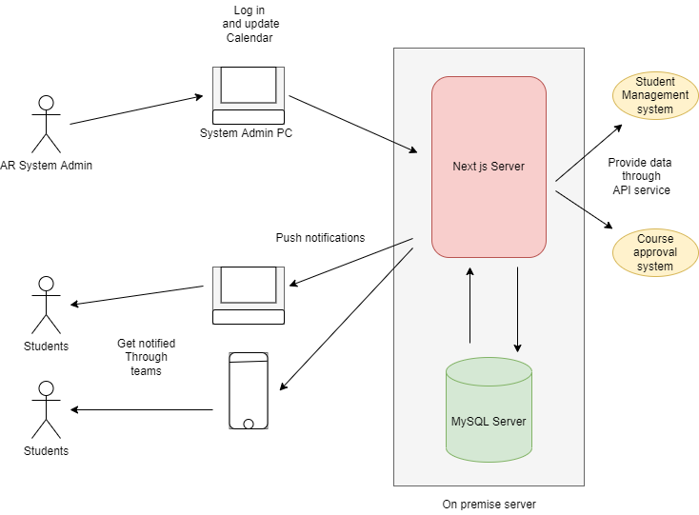Design Software Architecture
3. Development
   1. Divide chosen feature into five different tasks and do parallel
4. Testing
   1. Testing whether the UI is responsive or not
   2. Testing whether API is also working as required
   3. Load testing
5. Deployment
   1. Deploy the software developed, on premises server
6. Maintenance
   1. Collecting feedback from the client
   2. Based on feedback, add new requirements
7. Evolution
   1. After developing the software fully consider developing upgrades based on client requirements.
8. **Deployment**
   * This calendar management system is going to be hosted on the faculty on premises server.
   * For the software deployment process, we’ve planned to use both rolling method and the blue-green method. By using the blue-green method we can have a separate production environment and we can fully test the new features in that duplicate environment.
   * In case if we have to quickly deploy then we have planned to use the rolling method so that developed features can be embedded to the main application part by part quickly.
   * We have decided to use GitHub as our version control management system we can use the GitHub actions to automate our deployment process up to some extent.
9. **Testing**
   * Since our main development process is agile process development, testing, deployment process will be continuously driven again and again. Therefore, we have planned to use a test-driven approach so that each and every part in the software will be tested fully.
   * Our expectation is to provide best application with almost zero errors to the AR and Students so that they can freely use these features without any worries.
10. **Documentation**
    * As the development team we must ensure that the users have no questions about the product and for that we will provide them with the end-to-end full documentation.
    * Also, for the other developers who use our software’s API features we provide a full API documentation
11. **Warranty**
    * This is a software which we are developing for the Software Engineering module project and we have a limited timeframe to develop this, therefore, not agreements for the warranty will be given, but our expectation is to give our fully support for any questions and concerns.
12. **Support**
    * As in the above scenario there will be no support agreements will be given, but we will be looking forward to give any support for any user who uses this service.

**Pricing and payment**

* + This software application will be offered free of charge for Faculty of Engineering University of Jaffna and they have full permission to use and modify this software on behalf of their own purpose.

**Contact us**

* + Name: Perera U.L.L.K. (Team Leader)
  + By phone: 0762434735
  + Email: [2018e091@eng.jfn.ac.lk](mailto:2018e091@eng.jfn.ac.lk)

Feel free to contact us for any reason.